Complexity Analysis

1. Sum Rule
2. Product Rule

Sum Rule:

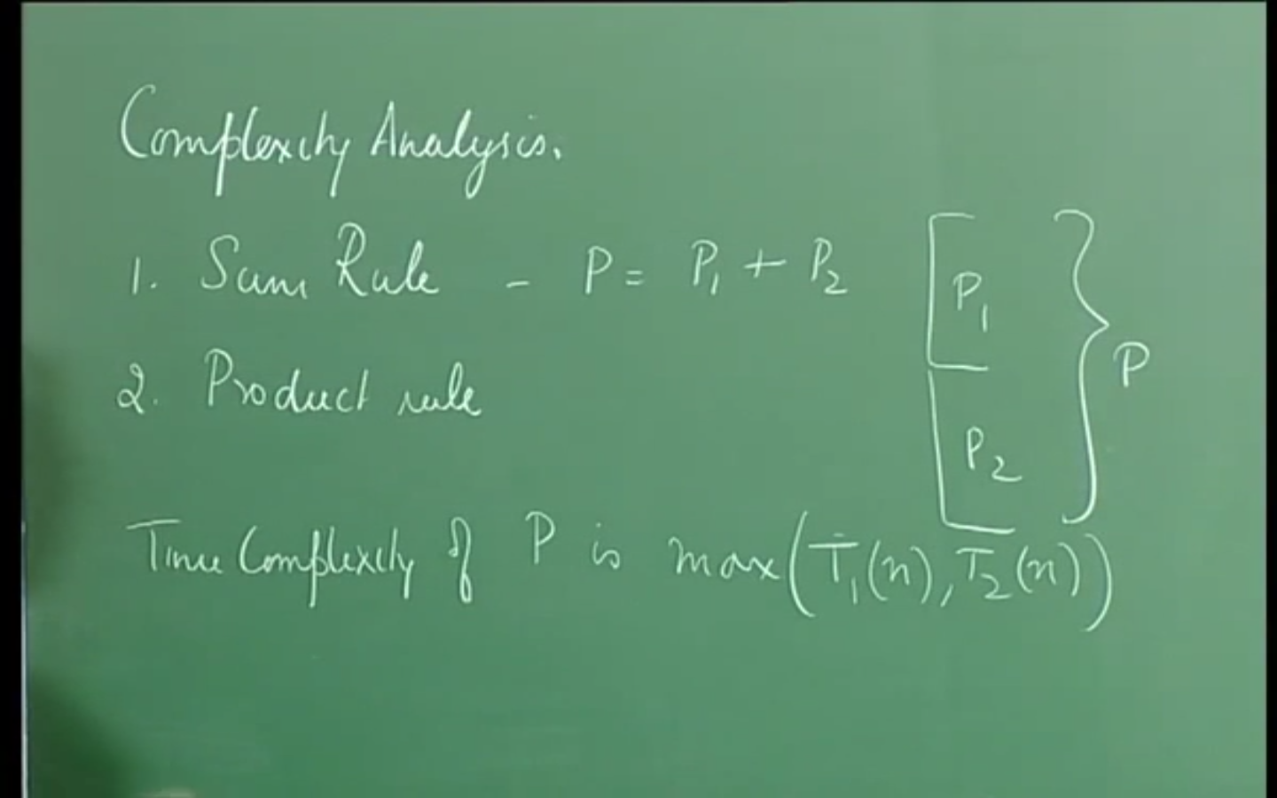

Product Rule:

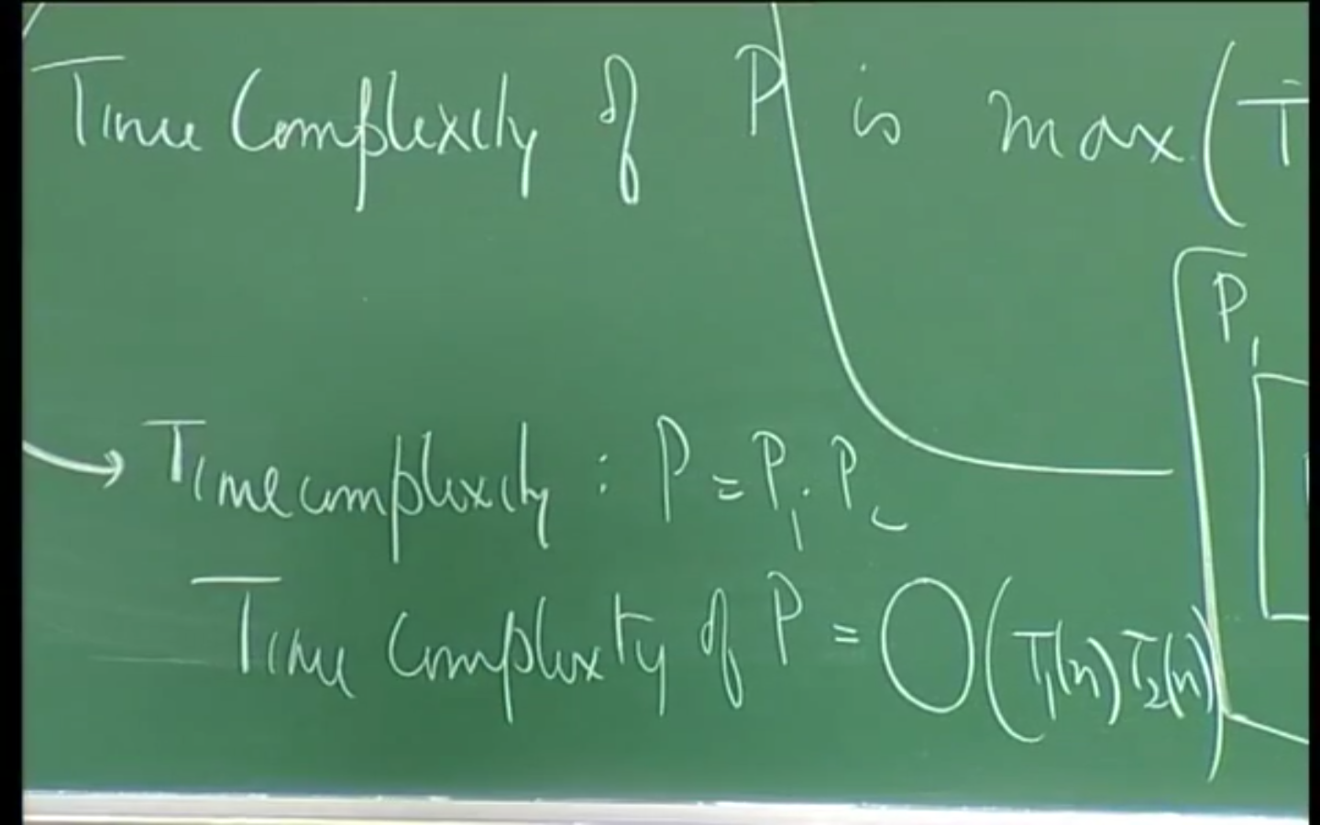

Example: Complexity Analysis

sum = 0; O(1)
for (i = 0; i < n; i++) max(O(1) , O(1) , O(1)) = O(1)
sum = sum + a[i]; O(1)

Time Complexity for each segment of each loop:

max(O(1), O(1)) = O(1)

Time Complexity for thr For loop:

O(n + 1) = O(n)

Time Complexity for program segment:

max(O(1), O(n)) = O(n)

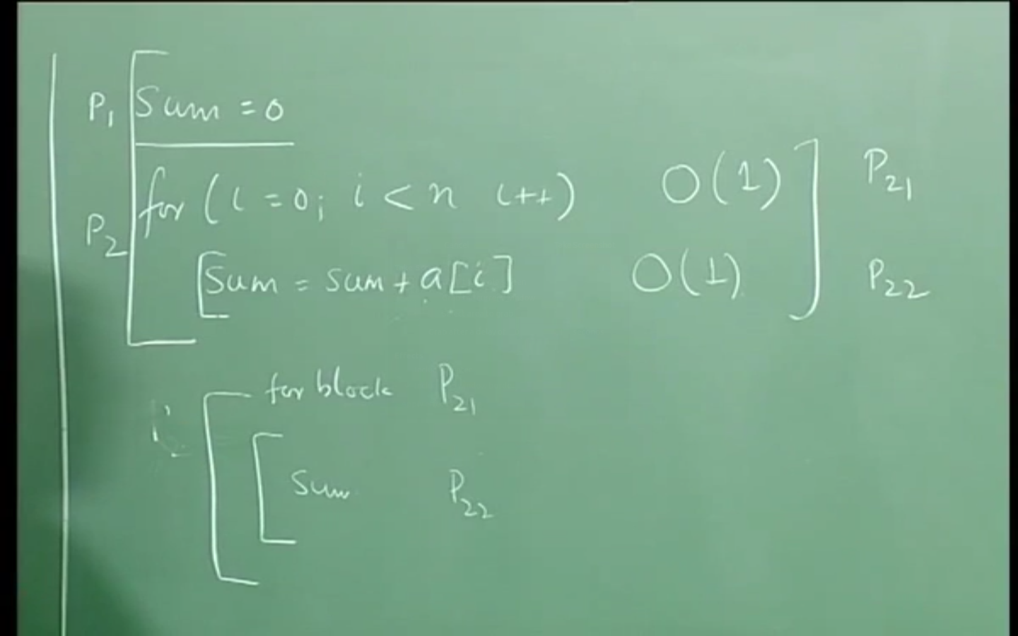

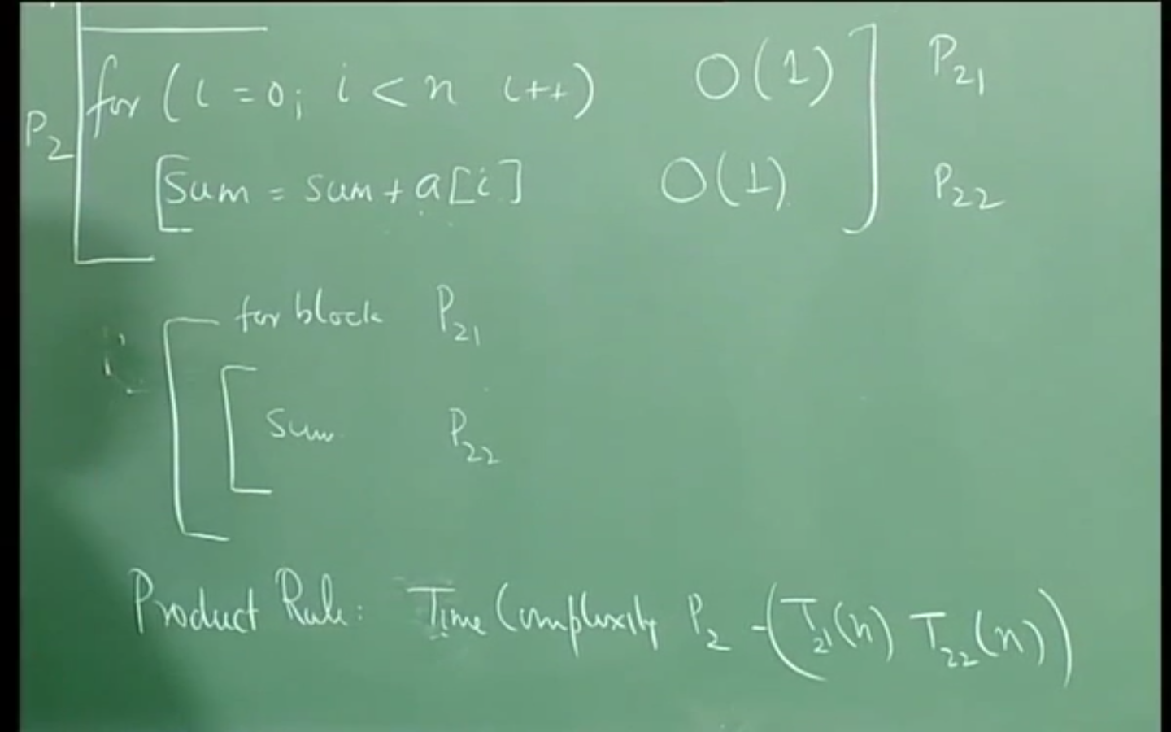

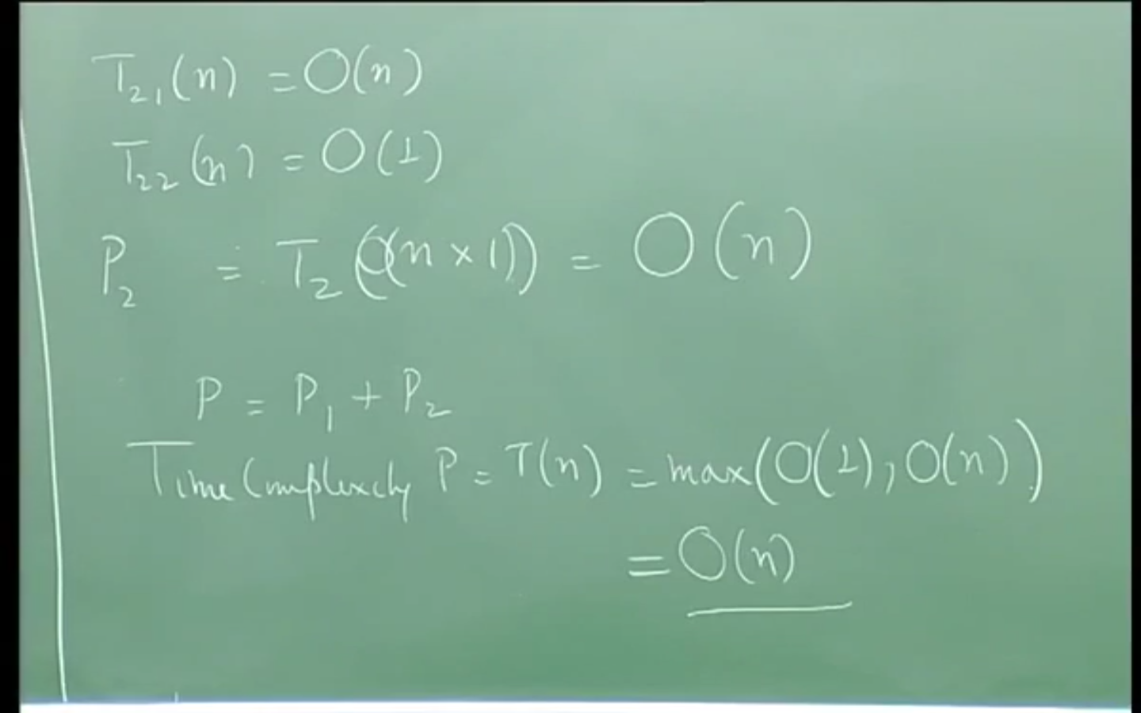

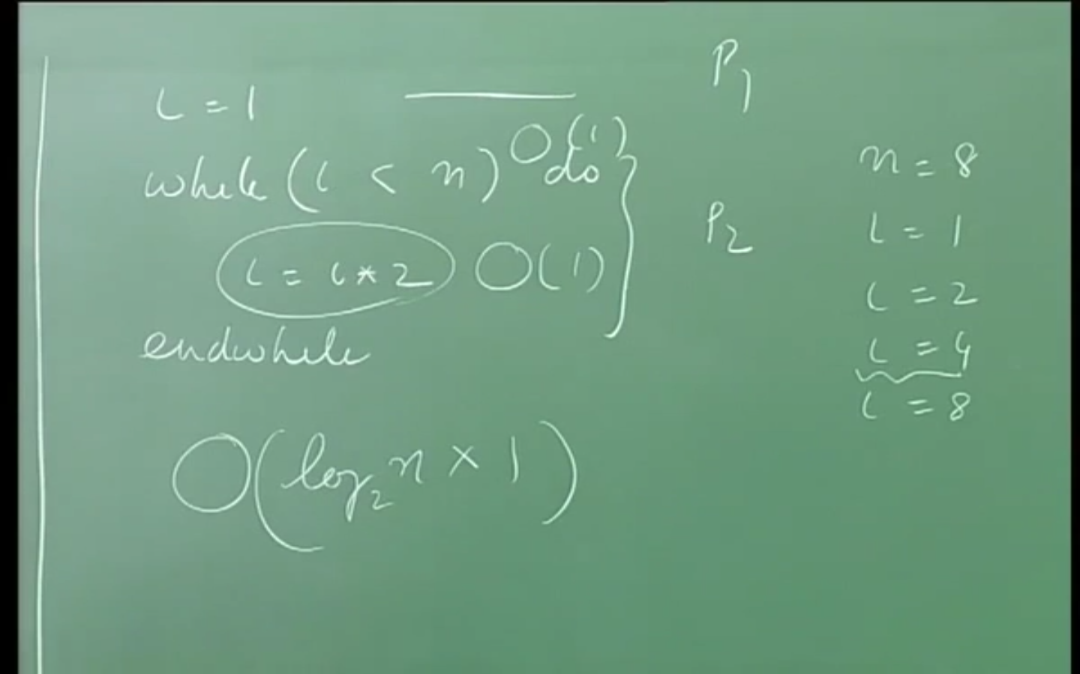
[ How many times the loop is executed. And multiplying the number of times the loop is executed with the cost of the operation within the loop. That is how we define Time Complexity ]

Time Complexity of recursive function:

int fact (int n) {
int value;
if (n <= 1) O(1)
value = 1; O(1)
else
value = n * fact (n – 1); O(1) + T(n – 1)
return value;
}
Time Complexity Analysis:

T(n) = c + T(n – 1), if n > 1
= d, if n <= 1
In general,

T(n) = ic + T(n – i) if n > 1

when i = n – 1 then

T(n) = c(n – 1) + T(1)
= c(n – 1) + d // d is the cost to the last call to the recusrion
= O(n)

